User Experience Engineering



**Sketches, Wireframes and Prototypes Group – 2021S2_REG_WE_62**

Table of Contents

Contribution to the report 03

Sketches, wireframes and prototypes 04

Member 1 – IT19164304 04

Member 2 – IT19159454 07

Member 3 – IT19022116 13

Prototype version 1.0 16

Feedback 17

Video link 17

Script 17

Prototype version 2.0 18

## Contribution to the report

|  |  |  |
| --- | --- | --- |
| **Reg No** | **Name** | **Contribution** |
| IT19164304 | Ramanayake A.R.D.Y. Y | Sketches, wireframes of the video consulting, channeling history, channel details pages.  Prototype of welcome page, login page, home page, registration page, video consultant page, Channeling history page, Channel details page |
| IT19159454 | Fernando P.P. A | Sketches, wireframes and prototype of the Medical Lab Homepage, Medical Lab Dashboard, Prescription details page, Lab Test Details Page, Drug Delivery page, Payment Methods page, My Card Details page, Visa Card Details page, Master Card Details page |
| IT19022116 | Prasad R.M | Main functionality UIs are Channeling Private hospital doctors and Channeling ayurvedic hospital doctors. The entire process goes through few user interfaces such as doctors profile UI, booking details UI, Booking UI. For all those main and sub interfaces, sketches, wireframes and prototypes have been designed. |

**Member 1: Ramanayake A.R.D.Y.Y – IT19164304**

**Video consultation**

**\*.** In this UI user can channel a doctor via video call or online. User can select the hospital and doctor after clicking the proceed button, some messages go to doctor after can doctor connect the patient.

|  |  |  |
| --- | --- | --- |
| **I. Sketches of the video consulting page**   | **II. Wireframe of the video consulting page**   | **III. Prototype of the video consulting page**   |

**Channeling History**

*. In this UI user can see channeling history so user can see all of channels he has ever done past.

|  |  |  |
| --- | --- | --- |
| **I. Sketches of the Channeling History**   | **II. Wireframe of the channeling history**   | **III. Prototype of the channeling history** |

**Doctor Details**

*. In this UI user can see the details of clicked item of channeling history. User can see the image and additional info also.

|  |  |  |
| --- | --- | --- |
| **I. Sketches of the Channeling details**   | **II. Wireframe of the channeling details**   | **III. Prototype of the channeling details**   |

**Sub prototypes I have created (IT19164304)**

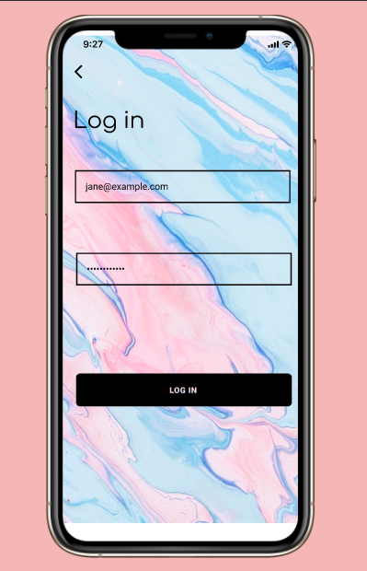

Register main menu login

Flow of the pages of chat application

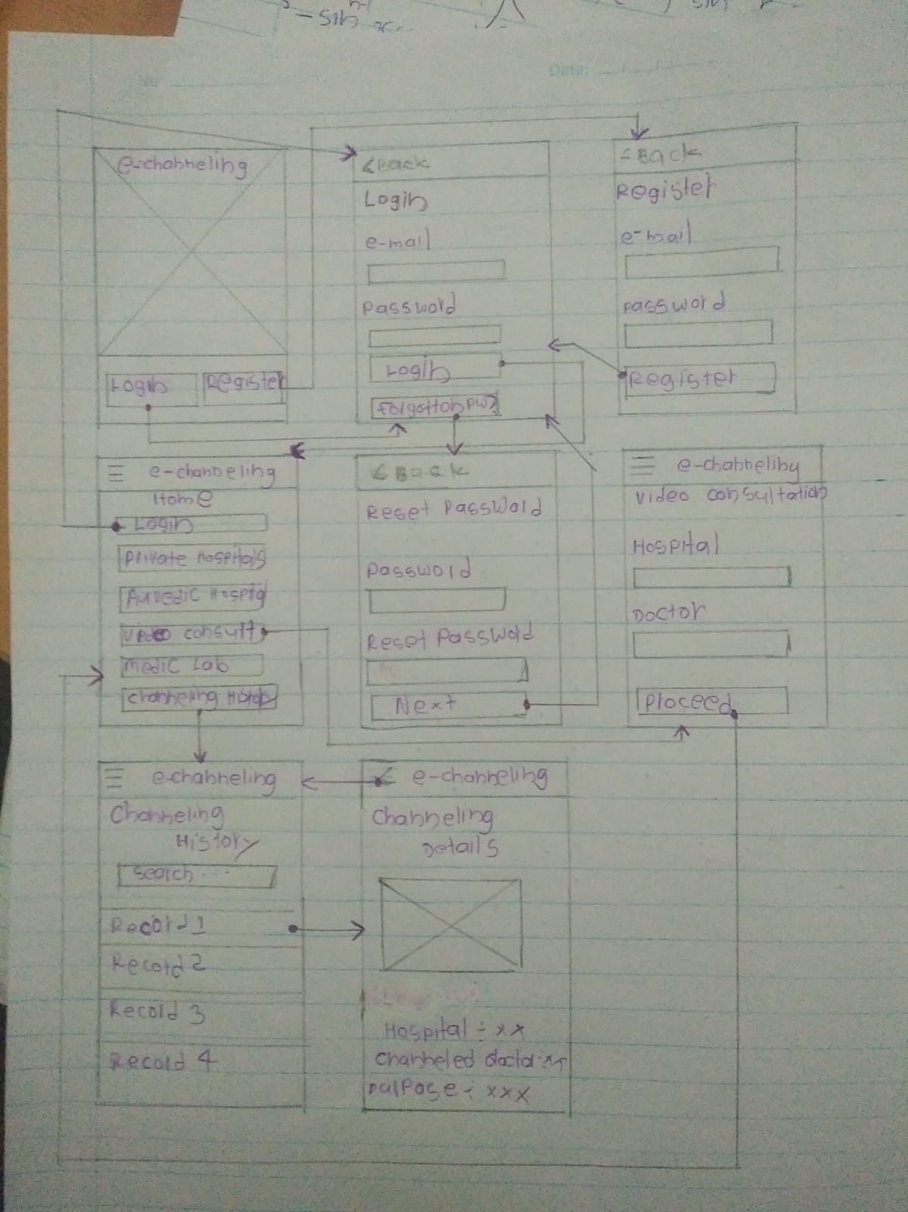

**Member 2: Fernando P.P.A – IT19159454**

**Medical Lab Homepage**

|  |  |  |
| --- | --- | --- |
| **I. Sketches of the medical lab homepage** | **II. Wireframe of the medical lab homepage** | **III. Prototype of the medical lab homepage** |

**Medical Lab Dashboard**

*. In this UI User can clicking those buttons and user can redirect to the specific interface.

|  |  |  |
| --- | --- | --- |
| **I. Sketches of the medical lab Dashboard** | **II. Wireframe of the medical lab Dashboard** | **III. Prototype of the medical lab Dashboard** |

**Prescription details page**

*. In this UI user can easily fill on details on prescription uploading.

|  |  |  |
| --- | --- | --- |
| **I. Sketches of the prescription details** | **II. Wireframe of the prescription details** | **III. Prototype of the prescription details** |

**Lab Test Details Page**

*. In this UI user can easily fill on details on lab test uploading.

|  |  |  |
| --- | --- | --- |
| **I. Sketches of the lab test details** | **II. Wireframe of the lab test details** | **III. Prototype of the lab test details** |

**Drug Delivery page**

*. In this UI user can find the details of the drugs that they want to get delivered and they can proceed to the payment.

|  |  |  |
| --- | --- | --- |
| **I. Sketches of the Drug Delivery details page** | **II. Wireframe of the Drug Delivery details page** | **III. Prototype of the Drug Delivery details page** |

**Payment Methods page**

*. In this UI user can easily identify the available payment gateways.

|  |  |  |
| --- | --- | --- |
| **I. Sketches of the payment methods** | **II. Wireframe of the payment methods** | **III. Prototype of the payment methods** |

**My Card Details page**

*. In this UI user can see the saved card details to the system and if user want to add new one, they can add it by simply click on add button. And they can delete the saved card details.

|  |  |  |
| --- | --- | --- |
| **I. Sketches of the card details page** | **II. Wireframe of the card details page** | **III. Prototype of the card details page** |

**Visa Card Details page**

*. In this UI user can add visa card details by filling this form.

|  |  |  |
| --- | --- | --- |
| 1. **Sketches of the add visa card details** | 1. **Wireframe of the add visa card details** | **III. Prototype of the medical lab Dashboard** |

**Master Card Details page**

*. In this UI user can add master card details by filling this form.

|  |  |  |
| --- | --- | --- |
| **I. Sketches of the add master card details** | **II. Wireframe of the add master card details** | **III. Prototype of the add master card details** |

**Sub prototypes I have created (IT19159454)**

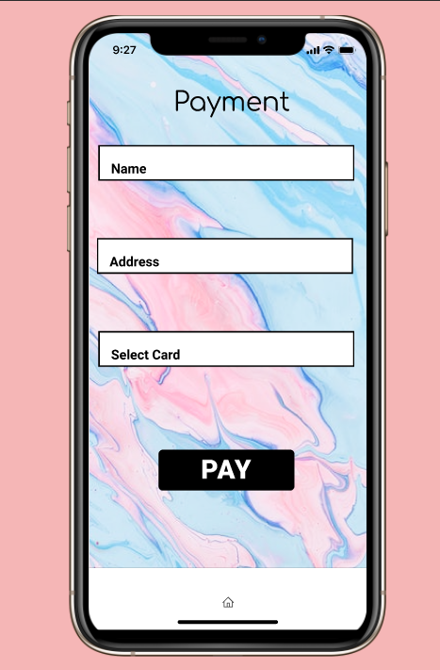

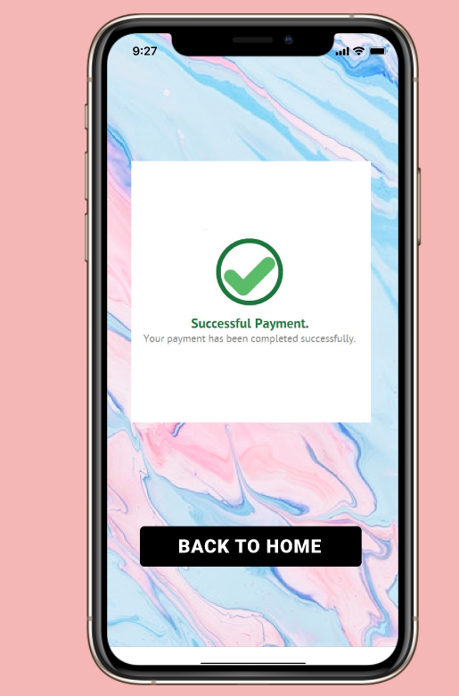

Flow of the pages of chat application

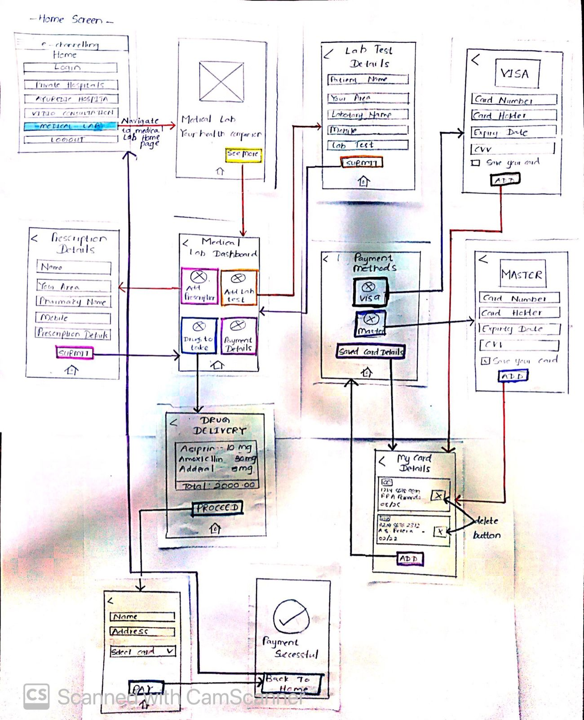

**Member 3: Prasad R.M – IT19022116**

**Private Hospital Doctors Channeling**

*. From this UI patients can search doctor by their name if they know the name of the doctors, otherwise patient can search by category and get the list of doctors relevant the category.

|  |  |  |
| --- | --- | --- |
| 1. Sketch private hospital doctor channeling | Wireframe private hospital doctor channeling | Prototype private hospital doctor channeling |

*. If patient search by category, patient will direct to this interface where all the specialist related to certain category can be seen here.

|  |  |  |
| --- | --- | --- |
| Sketch | Wireframe | Prototype |

**Doctors Details User Interface**

*. Here patient can see the doctor’s profile, feedbacks given by previous patient, available dates and hospitals.

|  |  |  |
| --- | --- | --- |
| Sketch | Wireframe | Prototype |

**Channeling Details**

*. Patient can see all the channeling details of the relevant channel.

|  |  |  |
| --- | --- | --- |
| Sketch | Wireframe | Prototype |

Ayurvedic Doctors channeling procedure is also same as that with similar user interfaces

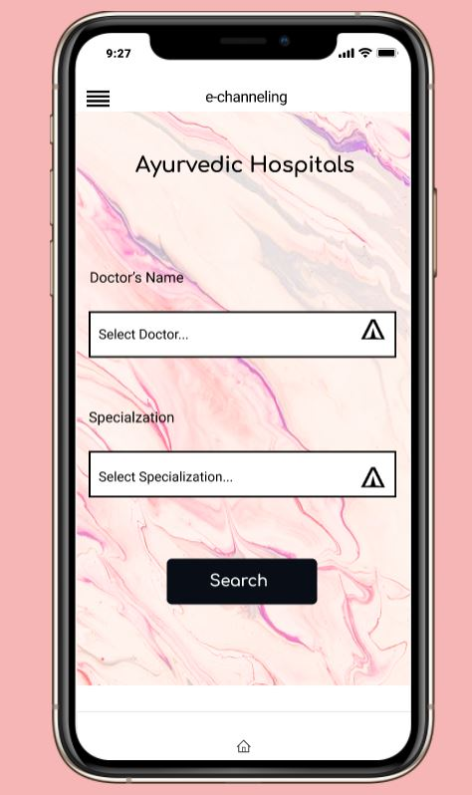 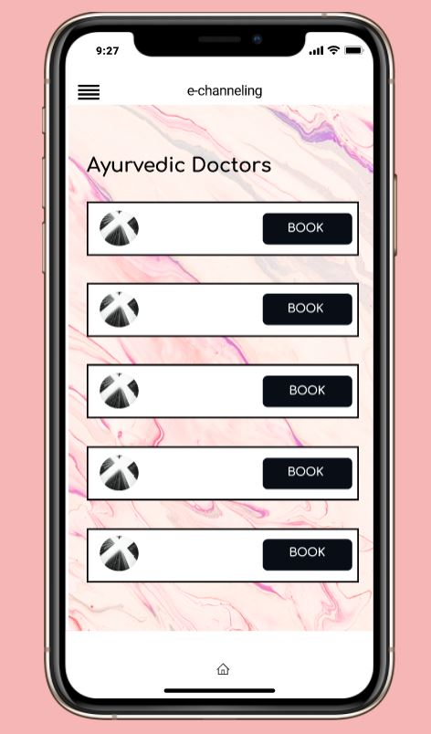

## **Prototype Version 1**

# Prototype – version 1.0

Design Tool – Figma

## Figma design link - [**https://www.figma.com/file/C3kOisX3uFFKDQAJtT6r9v/version1?node-id=0%3A1**](https://www.figma.com/file/C3kOisX3uFFKDQAJtT6r9v/version1?node-id=0%3A1)

Prototype link - <https://www.figma.com/proto/C3kOisX3uFFKDQAJtT6r9v/version1?node-id=0%3A2&scaling=scale-down&page-id=0%3A1&starting-point-node-id=0%3A2&show-proto-sidebar=1>

## **Prototype of the entire application version 1.0**

## 

**Feedback**

**Video link -** <https://drive.google.com/file/d/1s9UgETPY0bURiiyECkcNnsZNPaRYMIC/view?usp=sharing>

**Script Introduction**

Ramanayake A.R.D.Y. Y - Hi Sandaru, we are students of 3rd year second semester of SLIIT.

We develop a mobile application to channel doctors, drug delivery etc. We invited for you to give some recommendation for our E-channeling mobile application. If you have any doubt regrading this mobile application, you can say because it is a good way to improve the mobile application for us.

So firstly, this is the first impression of e-channeling mobile application, I mean this is the welcome user interface of the mobile application.

Ramanayake A.R.D.Y. Y - What do you think about this UI Sandaru?

**Answer - I think its fine.**

Ramanayake A.R.D.Y. Y - Images, color is it okay or want to be change the first main page?

**Answer - No, it okay.**

Ramanayake A.R.D.Y. Y - User can click the register button in the main UI and goes to this register page what do you think about this UI anything to improve.

**Answer - mmm. It seems fine. Nothing to change**

Ramanayake A.R.D.Y. Y - After that, by clicking the login button in our welcome page we go to the login UI as well user can type user email and password and after login. what do you think about that UI Sandaru? do you have any doubts about this?

**Answer - Mumm. I think it’s better if you can add the forgotten password button. Its only.**

Ramanayake A.R.D.Y. Y - Thank for your idea Sandaru, we will do that in prototype version 2. After that clicking the login button it goes to our home page, in the home page included the menu. From the menu I click firstly video consultation category .in this UI what do you think Sandaru anything wants to change?

**Answer - It seems fine.**

Ramanayake A.R.D.Y. Y - in the main menu has section called channeling history .in this ui has channeling history of used. After click one list item user can see channeling details of one channel. What do you think about those 2 UI Sandaru?

**Answer – I think it seems fine. No worries.**

Ramanayake A.R.D.Y. Y - Okay thanks Sandaru. After that we direct to private hospitals category. Madura will continue this.

Prasad R.M - In this UI user can select doctor and specialization after that user can search the doctor, after click search button, it goes to next page in next page have doctor with selected specialization. so, user can book a doctor. After book it goes to the doctor details page, in this page have doctor’s profile and previous patient’s feedbacks and user must and booking date and book that doctor. So sandaru what do you think about those UI's? is there any mistakes or something which must be improved in those user interfaces?

**Answer - I think all subtitles must be capitalized. If you can do that could be great.**

Ramanayake A.R.D.Y. Y -Okay thanks sandaru we will correct those mistakes in version 2 prototype. After that in menu bar have medic lab and this will be continued by Pubudi.

Fernando P.P. A - okay thanks...By click the medic lab it goes to medic lab dashboard, in the dashboard user can see sections called add prescriptions, add lab test, taking drugs and payment. In add prescription user can add their prescriptions, in lab test UI user can add their lab test and finally can do the payment with entering the card details like this UI. What do you think about this UI Sandaru, there anything to change?

**Answer – Yes. Can you please move to prescription details page.in this UI it better if you can make the header as one line and add lab test, drug to take UI also want to be change like that. Another one if you can add contact information in payment page it would be great. Another one I noted, in payment UI, buttons font size is bit larger.**

Ramanayake A.R.D.Y. Y - that’s all for our UI sandaru we will correct those mistakes while creatin prototype version 2. Thanks for your contribution sandaru. Have a nice da

**Answer - Okay. Good job guys.**

## Prototype Version 2

# Prototype – version 2.0

Design Tool – Figma

## Figma design link - [**https://www.figma.com/file/kidocgtmZzCUIlQ7EAMRbE/version2?node-id=0%3A1**](https://www.figma.com/file/kidocgtmZzCUIlQ7EAMRbE/version2?node-id=0%3A1)

Prototype link - <https://www.figma.com/proto/kidocgtmZzCUIlQ7EAMRbE/version2?node-id=22%3A1084&scaling=scale-down&page-id=0%3A1&starting-point-node-id=22%3A1084&show-proto-sidebar=1>

## **Prototype of the entire application version 2.0**

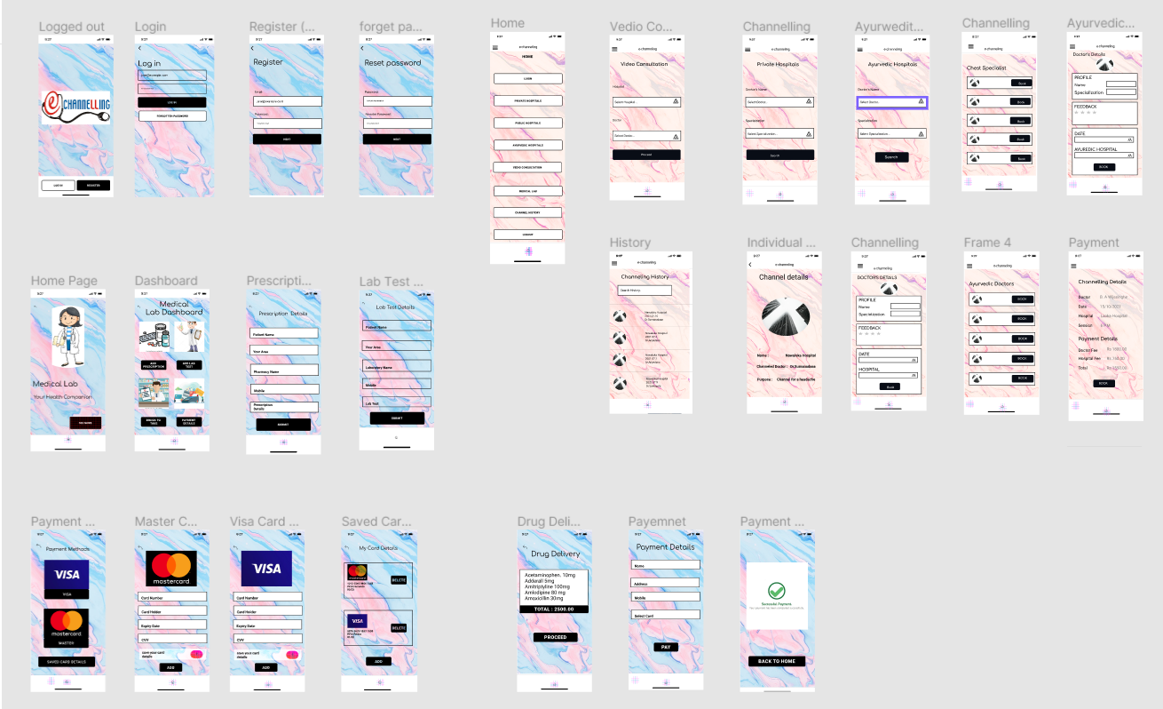

**Changes in version 2.0**

1. Forget password button added to the login UI.

1. Reset password page added.

1. Mobile number field added to the delivery details page UI.

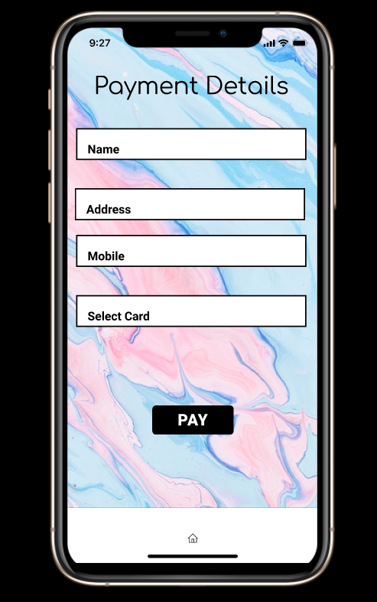

1. Title changed to the one line.

